PRG_CAM · PROJECT REVIEW & TRAINING SERIES

05
Python 接收机架构与演进
从 Npcap Ethernet frame 到 COMPLETE / RECOVERED 图像：协议、会话、队列和存储

适用对象 | 具备基础 Verilog/Python，正在学习 Vivado、Ethernet 与端到端调试的工程人员
范围 | CLI、Layer1–5、Camera协议、重组、恢复、异步输出、Storage/Audit/Monitor与pytest
当前状态 | 自动测试：PASS（88项）；优化后的正式120秒live验收：PENDING
事实基线 | 当前源码/.xpr > 当前报告/测试/PCAP/CSV > Git > 技术文档 > 历史推测
来源重组 | 本主题无一一对应旧Word；根据当前Python源码、Git diff、p11、attempt3和技术文档重建

阅读约束：本文把 PASS、PARTIAL、PENDING 分开。实现时序通过不等于板级通过；ILA 只增加可观察性；LAST_ROW 只表示看见帧尾标志，不等于 480 行完整。
版本：Phase 1 training set · 2026-07-28

目录
在 Word 中打开后更新目录
提示：本目录为 Word 字段。若页码未自动刷新，右键目录选择“更新域 → 更新整个目录”。

1. 事实边界与软件入口
本章目标｜先区分代码测试通过、离线PCAP通过和真实live性能通过。

表 1-1 当前Python状态
项目 | 状态 | 证据/边界
全量pytest | PASS | 88 passed in 5.20s
Fixed PCAP Layer1/2 | PASS | 1000帧及229629帧00..7F
Layer3协议/CRC/flags | PASS（测试） | packet_format/camera_parser
跨帧隔离/zero-fill | PASS（测试） | reassembler/image recovery tests
attempt3输出一致性 | PASS（有限） | PGM/RAW mismatch=0；zero-fill failure=0
attempt3性能 | FAIL/PARTIAL | 82,135 capture queue drops；usable 8.453fps
性能优化后120秒 | PENDING | 尚无同条件final report
重要口径｜packet rate不是image fps；LAST_ROW次数不是完整图数量；RECOVERED是输出策略，不是Reassembler的FrameStatus枚举。

2. Layer1–5、线程与两类有界队列
图 2-1 Python接收机的当前真实调用链
表 2-1 层级与职责
阶段 | 主要文件 | 输入→输出 | 失败行为
Layer1 | capture.py | NIC/PCAP→RawEthernetFrame | 权限/接口/捕获错误
Capture queue | pipeline.py | frame对象→packet worker | live满则drop
Layer2 | eth_validate.py | Ethernet→payload | MAC/type/length失败
Layer3 | camera_parser.py | 128B→CameraPacket | 带reason严格拒绝
Layer4 | stream_monitor.py | packet→统计 | gap/duplicate/out-of-order
Layer5 | reassembler.py | row packets→session | partial/corrupt/timeout
Output queue | async_sink.py | CompletedFrame→worker | 满时阻塞
Storage/Image | storage.py/image_pipeline.py | frame→RAW/PGM/JSON/CSV | 原子写/失败计数
图 2-1 中两个queue不能混为一谈：Capture queue的数据单位是Ethernet包；Frame output queue的数据单位是已关闭图像会话。

3. 128-byte Camera payload
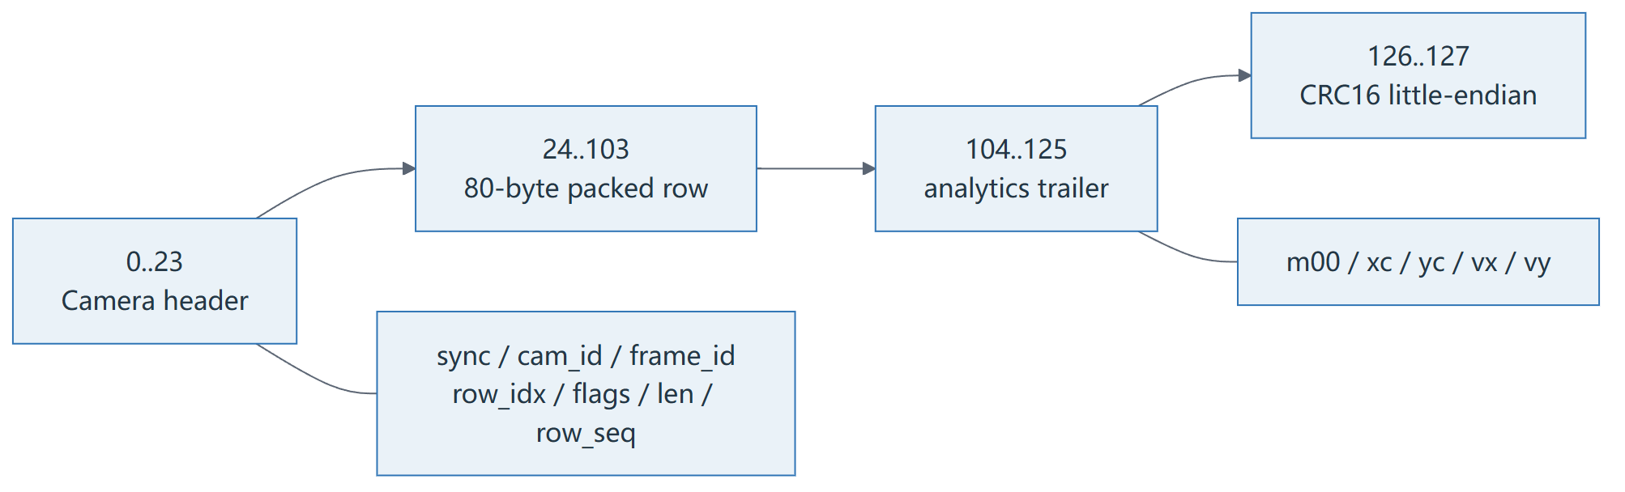
图 3-1 Camera header、packed row、trailer与CRC16边界
表 3-1 当前payload逐字节字段
Offset | 长度 | 字段 | 端序/语义
0 | 2 | sync0 | 0xA5A0，线上A5 A0
2 | 2 | sync1 | 0x5A50，线上5A 50
4 | 1 | cam_id | 0..3
5 | 2 | frame_id | 大端
7 | 2 | row_idx | 大端，0..479
9 | 1 | row_flags | 0x01 overflow/0x02 last/0x04 first/0x08 length
10 | 1 | payload_len | 有效packed row bytes
11 | 2 | row_seq | 大端，16-bit连续计数
13 | 11 | reserved | 当前保留
24 | 80 | row payload | 640像素1bpp packed
104 | 10 | trailer pad | 应为0
114 | 12 | m00/xc/yc/vx/vy | 大端，vx/vy signed
126 | 2 | CRC16 | 小端，覆盖0..125
代码对照｜协议常量、flag和struct
0028 | HEADER_LEN = 24
0029 | TRAILER_LEN = 24
0030 | PACKET_LEN = 128
0031 | ROW_BYTES = PACKET_LEN - HEADER_LEN - TRAILER_LEN # 80
0032 |
0033 | # Current RP2350A wire semantics, confirmed against the live attempt2 CSV:
0034 | # bit 0 reports a frame/line-buffer overflow, bit 1 terminates the frame, and
0035 | # bit 2 marks the first valid row. Older project-side code had bit 0 and bit 2
0036 | # swapped; that made every real 0x04 first-row packet look corrupt.
0037 | FLAG_FRAME_OVERFLOW = 1 << 0
0038 | FLAG_LAST_ROW = 1 << 1
0039 | FLAG_FIRST_ROW = 1 << 2
0040 | FLAG_LENGTH_ERROR = 1 << 3
0041 |
0042 | # Protocol word values and their expected MSB-byte-first wire representation.
0043 | # This is byte order inside each multi-byte metadata field; it is not an
0044 | # MSB/LSB bit reversal inside an individual byte.
0045 | SYNC0_DEFAULT = 0xA5A0
0046 | SYNC1_DEFAULT = 0x5A50
0047 | SYNC_BYTES_DEFAULT = struct.pack(">HH", SYNC0_DEFAULT, SYNC1_DEFAULT)
0048 | assert SYNC_BYTES_DEFAULT == bytes.fromhex("a5a05a50")
0049 |
0050 | _LEGACY_SYNC_BYTES = bytes.fromhex("a5a55a5a")
0051 |
0052 | # ---- pkt_row_header_t ---------------------------------------------------
0053 | # uint16 sync0, uint16 sync1, uint8 cam_id, uint16 frame_id, uint16 row_idx,
0054 | # uint8 row_flags, uint8 payload_len, uint16 row_seq, uint8 reserved[11]
0055 | _HEADER_STRUCT_BE = struct.Struct(">HHBHHBBH11s")
0056 | _HEADER_STRUCT_LE = struct.Struct("<HHBHHBBH11s")
0057 | assert _HEADER_STRUCT_BE.size == HEADER_LEN
0058 | assert _HEADER_STRUCT_LE.size == HEADER_LEN
0059 |
0060 | # ---- plt_row_trailer_t ---------------------------------------------------
0061 | # uint8 pad[10], uint32 m00, uint16 xc_q4, uint16 yc_q4,
0062 | # int16 vx_q8, int16 vy_q8, uint16 crc16
0063 | _TRAILER_BODY_STRUCT_BE = struct.Struct(">10sIHHhh")
0064 | _TRAILER_BODY_STRUCT_LE = struct.Struct("<10sIHHhh")
0065 | assert _TRAILER_BODY_STRUCT_BE.size == TRAILER_LEN - 2
0066 | assert _TRAILER_BODY_STRUCT_LE.size == TRAILER_LEN - 2
0067 |
0068 | # Everything except the trailing crc16 -- this is exactly what the CRC
0069 | # is calculated over (mirrors the original code's payload[:126]).
0070 | _CRC_COVERED_LEN = PACKET_LEN - 2
0071 | _BODY_STRUCT_BE = struct.Struct(f">HHBHHBBH11s{ROW_BYTES}s10sIHHhh")
0072 | _BODY_STRUCT_LE = struct.Struct(f"<HHBHHBBH11s{ROW_BYTES}s10sIHHhh")
0073 | assert _BODY_STRUCT_BE.size == _CRC_COVERED_LEN
0074 | assert _BODY_STRUCT_LE.size == _CRC_COVERED_LEN
证据：D:\prg\prg_cam\prg_cam.srcs\sources_1\tx\taxi_receiver_advanced\taxi_receiver\taxi_receiver\packet_format.py:28
0x58不是新flag｜合法flag集合只定义低4位。attempt3中的0x58与字段错位/短行相符，不能通过“新增0x58定义”来掩盖。

4. Layer1 Capture 与 Layer2 Ethernet Decode
代码对照｜Npcap/Scapy BPF与按需raw frame复制
0071 | def start(self, on_frame: Callable[[RawEthernetFrame], None]) -> None:
0072 | from scapy.all import AsyncSniffer
0073 | from scapy.layers.l2 import Ether
0074 |
0075 | def _callback(packet) -> None:
0076 | if Ether not in packet:
0077 | return
0078 | eth = packet[Ether]
0079 | on_frame(RawEthernetFrame(
0080 | src_mac=eth.src,
0081 | dst_mac=eth.dst,
0082 | ethertype=int(eth.type),
0083 | payload=bytes(eth.payload),
0084 | # The complete second byte copy is needed only when the
0085 | # optional PCAP recorder is enabled.
0086 | raw_bytes=bytes(packet) if self.include_raw else b"",
0087 | timestamp=time.time(),
0088 | ))
0089 |
0090 | self._sniffer = AsyncSniffer(
0091 | iface=self.interface,
0092 | filter=f"ether proto 0x{self.ether_type:04x}",
0093 | prn=_callback,
0094 | store=False,
0095 | )
0096 | self._sniffer.start()
证据：D:\prg\prg_cam\prg_cam.srcs\sources_1\tx\taxi_receiver_advanced\taxi_receiver\taxi_receiver\capture.py:71
- BPF在capture层使用ether proto 0x88b5，降低无关帧进入Python。
- payload始终转成独立bytes；只有启用PCAP录制时才复制整个bytes(packet)。
- 因此取消第二次完整frame复制后，减少CPU、内存带宽和对象分配，同时不依赖Scapy底层buffer生命周期。
- Layer2校验dst/src/type/最小长度；Wireshark灰色duplicate不是自动坏帧判据。
代码对照｜Capture queue的live drop与offline背压
0134 | # ---- Layer 1 -> queue hand-off (runs on the capture thread) -------
0135 |
0136 | def _on_frame(self, frame: RawEthernetFrame) -> None:
0137 | self.monitor.record_ethernet_frame()
0138 | if self.lossless_input:
0139 | while not self._stop_event.is_set():
0140 | try:
0141 | self._queue.put(frame, timeout=0.2)
0142 | self.monitor.record_capture_queue_depth(
0143 | self._queue.qsize()
0144 | )
0145 | return
0146 | except queue.Full:
0147 | continue
0148 | return
0149 | try:
0150 | self._queue.put_nowait(frame)
0151 | self.monitor.record_capture_queue_depth(self._queue.qsize())
0152 | except queue.Full:
0153 | self.monitor.record_dropped_capture()
0154 |
0155 | # ---- worker thread: run every frame through the stage chain -------
0156 |
0157 | def _run_worker(self) -> None:
0158 | while not self._stop_event.is_set() or not self._queue.empty():
0159 | try:
0160 | frame = self._queue.get(timeout=0.2)
0161 | except queue.Empty:
0162 | for stage in self._reassembly_stages:
0163 | stage.poll_timeouts()
0164 | self.monitor.maybe_report()
0165 | continue
0166 |
0167 | try:
0168 | self._process_frame(frame)
0169 | except Exception as exc: # noqa: BLE001 -- keep the worker alive
0170 | # This boundary includes observer/storage callbacks as well as
0171 | # parsing stages. Calling every such exception a parser error
0172 | # made WinError 5 archive failures look like bad packet data.
0173 | self.monitor.stats.processing_errors += 1
0174 | print(f"[PROCESSING ERROR] {exc}", file=sys.stderr)
0175 | finally:
0176 | self._queue.task_done()
证据：D:\prg\prg_cam\prg_cam.srcs\sources_1\tx\taxi_receiver_advanced\taxi_receiver\taxi_receiver\pipeline.py:134

5. Layer3 严格解析
代码对照｜sync、payload_len、CRC和字段错误分类
0062 | def parse_camera_mode(payload: bytes) -> CameraModeResult:
0063 | if len(payload) != PACKET_LEN:
0064 | return CameraModeResult(
0065 | ok=False,
0066 | reason="bad_length",
0067 | received_len=len(payload),
0068 | errors=("bad_length",),
0069 | )
0070 |
0071 | packet = parse_camera_row(payload)
0072 | errors: list[str] = []
0073 | warnings: list[str] = []
0074 |
0075 | # Current protocol words are 0xA5A0/0x5A50 and the observed/expected raw
0076 | # Ethernet payload bytes are A5 A0 5A 50 (MSB byte first). There is no
0077 | # protocol-version field; reject another pair instead of silently parsing
0078 | # an incompatible layout.
0079 | if (
0080 | packet.header.sync0 != SYNC0_DEFAULT
0081 | or packet.header.sync1 != SYNC1_DEFAULT
0082 | ):
0083 | errors.append("bad_sync")
0084 |
0085 | # payload_len describes valid bytes inside the fixed 80-byte row payload.
0086 | # Zero is not rejected because the RP2350A source definition is absent;
0087 | # surface it as a warning until firmware defines whether an empty row is
0088 | # legal. A value larger than the physical field is unambiguously invalid.
0089 | if packet.header.payload_len > ROW_BYTES:
0090 | errors.append("payload_len_out_of_range")
0091 | elif packet.header.payload_len == 0:
0092 | warnings.append("zero_payload_len")
0093 |
0094 | if not packet.crc_ok:
0095 | errors.append("crc_error")
0096 |
0097 | # These flags are generated/ORed by the active FPGA capture path and make
0098 | # the packet unsuitable for image reconstruction even when its post-capture
0099 | # CRC is correct.
0100 | if packet.frame_overflow:
0101 | errors.append("frame_overflow")
0102 | if packet.length_error:
0103 | errors.append("length_error")
0104 |
0105 | return CameraModeResult(
0106 | ok=not errors,
0107 | reason=errors[0] if errors else "",
0108 | packet=packet,
0109 | received_len=len(payload),
0110 | errors=tuple(errors),
0111 | warnings=tuple(warnings),
0112 | )
证据：D:\prg\prg_cam\prg_cam.srcs\sources_1\tx\taxi_receiver_advanced\taxi_receiver\taxi_receiver\camera_parser.py:62
表 5-1 Layer3原则
检查 | 失败结果 | 为什么不放宽
固定128-byte长度 | bad length | 否则字段offset不可相信
A5A0/5A50 sync | bad_sync | 防止错位数据伪装成header
payload_len≤80 | out_of_range | 防止越过行payload
CRC16 | crc_error | Camera层完整性
保留/flag语义 | warning/error reason | 保留原始证据
Layer3失败包不会进入frame.rows。恢复模式也不会使用其payload；RECOVERED只对missing row_idx写一整行0。

6. Layer4 Monitor：统计与速率口径
代码对照｜producer/consumer、queue peak和最终报告
0196 | def final_report(self) -> None:
0197 | elapsed = time.monotonic() - self.stats.start_time
0198 | average_packets_per_second = (
0199 | self.stats.matching_frames / elapsed if elapsed > 0 else 0.0
0200 | )
0201 | producer_rate = (
0202 | self.stats.total_ethernet_frames / elapsed
0203 | if elapsed > 0
0204 | else 0.0
0205 | )
0206 | queue_drop_percent = (
0207 | self.stats.dropped_capture_queue
0208 | * 100.0
0209 | / self.stats.total_ethernet_frames
0210 | if self.stats.total_ethernet_frames
0211 | else 0.0
0212 | )
0213 | average_mbps = (
0214 | self.stats.total_payload_bytes * 8 / elapsed / 1_000_000 if elapsed > 0 else 0.0
0215 | )
0216 |
0217 | self.sink("\n============== FINAL REPORT ==============")
0218 | self.sink(f"Elapsed : {elapsed:.3f} s")
0219 | self.sink(f"Capture ingress : {self.stats.total_ethernet_frames}")
0220 | self.sink(f"Matching Ethernet : {self.stats.matching_frames}")
0221 | self.sink(f"Valid packets : {self.stats.valid_packets}")
0222 | self.sink(f"Bad Ethernet length : {self.stats.bad_ethernet_length}")
0223 | self.sink(f"Bad fixed payload : {self.stats.bad_fixed_payload}")
0224 | self.sink(f"CRC errors : {self.stats.bad_crc}")
0225 | self.sink(f"Parser errors : {self.stats.parser_errors}")
0226 | self.sink(f"Processing errors : {self.stats.processing_errors}")
0227 | self.sink(f"Capture queue drops : {self.stats.dropped_capture_queue}")
0228 | self.sink(
0229 | f"Capture queue peak : "
0230 | f"{self.stats.capture_queue_peak}/"
0231 | f"{self.stats.capture_queue_capacity}"
0232 | )
0233 | self.sink(f"Capture drop percent : {queue_drop_percent:.4f}%")
0234 | self.sink(f"Producer rate : {producer_rate:.2f} packets/s")
0235 | self.sink(
0236 | f"Consumer rate : "
0237 | f"{average_packets_per_second:.2f} packets/s"
0238 | )
0239 | self.sink(
0240 | f"Average packet rate : "
0241 | f"{average_packets_per_second:.2f} packets/s"
0242 | )
0243 | self.sink(f"Average payload rate : {average_mbps:.3f} Mb/s")
证据：D:\prg\prg_cam\prg_cam.srcs\sources_1\tx\taxi_receiver_advanced\taxi_receiver\taxi_receiver\stream_monitor.py:196
表 6-1 监控指标如何解释
指标 | 单位/起点 | 增长说明
producer_rate | matching Ethernet包/s | capture回调向队列提供速度
consumer_rate | 完成stage链的包/s | packet worker实际消费速度
queue_peak/capacity | 对象数 | 接近容量说明突发或长期积压
queue_drops | live队列满后主动丢弃包数 | Python接收链无法跟上
complete/recovered fps | 图像/s | 与packet rate完全不同
output failures | 完成帧输出失败次数 | 磁盘/worker异常

7. Layer5 FrameReassembler
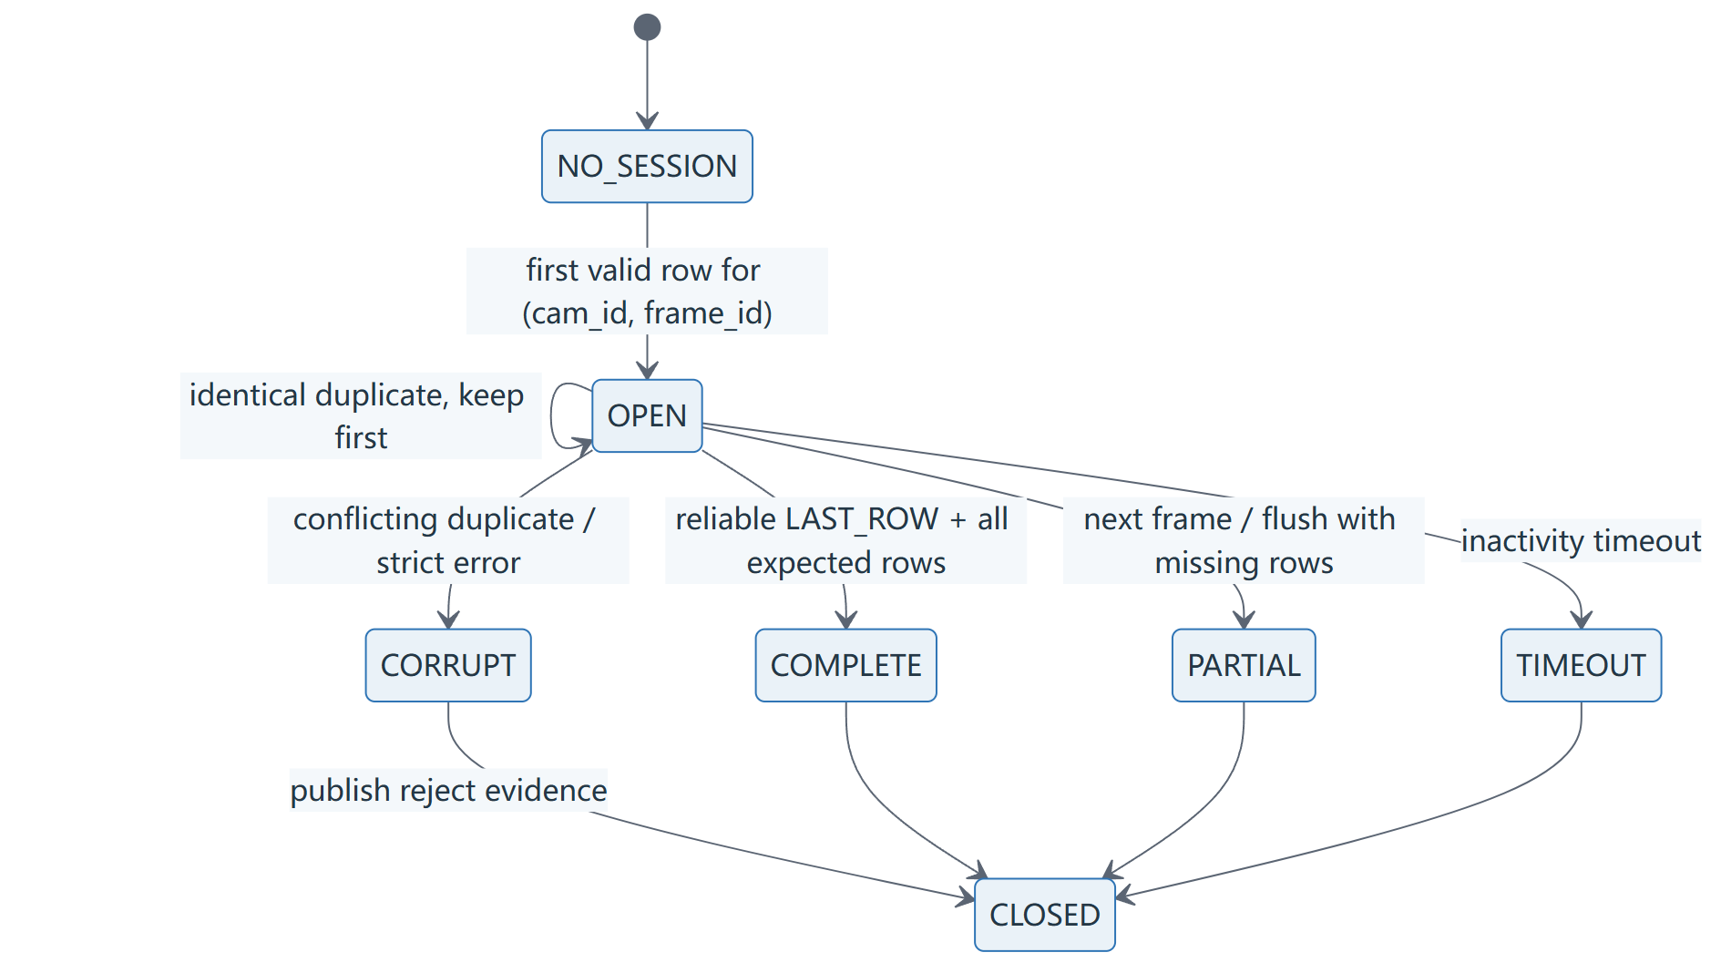
图 7-1 以(cam_id, frame_id)隔离的会话状态
代码对照｜session key、frame switch与严格row接收
0176 | cam_id = packet.header.cam_id
0177 | key = (cam_id, packet.header.frame_id)
0178 |
0179 | # A new frame ID for one camera closes that camera's older sessions,
0180 | # but never touches another camera's state. Equality is used instead
0181 | # of ordering so the 16-bit frame ID can wrap from 65535 to 0.
0182 | for old_frame_id in list(self._order.get(cam_id, [])):
0183 | if old_frame_id != packet.header.frame_id:
0184 | closed = self._close(
0185 | (cam_id, old_frame_id),
0186 | close_reason="frame_switch",
0187 | ended_at=event_time,
0188 | )
0189 | if closed is not None:
0190 | self._pending.append(closed)
0191 |
0192 | if key not in self._open:
0193 | self._evict_if_needed(cam_id, event_time)
0194 | self._open[key] = _FrameSession(
0195 | camera_id=cam_id,
0196 | frame_id=packet.header.frame_id,
0197 | started_at=event_time,
0198 | last_activity=event_time,
0199 | )
0200 | self._order.setdefault(cam_id, []).append(packet.header.frame_id)
0201 | self.stats.sessions_created += 1
0202 |
0203 | session = self._open[key]
0204 | session.last_activity = event_time
0205 | session.saw_first |= packet.first_row
0206 | session.saw_last |= packet.last_row
0207 | if packet.last_row:
0208 | session.last_row_idx = packet.header.row_idx
0209 | session.had_overflow |= packet.frame_overflow
0210 |
0211 | row_idx = packet.header.row_idx
0212 | payload = packet.payload[: packet.header.payload_len]
0213 | duplicate = row_idx in session.rows
0214 | conflict = duplicate and session.rows[row_idx] != payload
0215 | accepted = not errors and not duplicate
0216 | if accepted:
0217 | self.stats.rows_accepted += 1
0218 | else:
0219 | self.stats.rows_rejected += 1
证据：D:\prg\prg_cam\prg_cam.srcs\sources_1\tx\taxi_receiver_advanced\taxi_receiver\taxi_receiver\reassembler.py:176
代码对照｜missing_rows、status与不可变快照
0325 | if self._configured_expected_rows is not None:
0326 | expected = self._configured_expected_rows
0327 | elif session.last_row_idx is not None:
0328 | expected = session.last_row_idx + 1
0329 | else:
0330 | expected = max(session.rows, default=-1) + 1
0331 | missing = [i for i in range(expected) if i not in session.rows]
0332 |
0333 | corrupt = bool(session.errors) or session.had_overflow
0334 | if corrupt:
0335 | status = FrameStatus.CORRUPT
0336 | elif close_reason == "timeout":
0337 | status = FrameStatus.TIMEOUT
0338 | elif session.saw_last and not missing:
0339 | status = FrameStatus.COMPLETE
0340 | else:
0341 | status = FrameStatus.PARTIAL
0342 |
0343 | completed = CompletedFrame(
0344 | camera_id=session.camera_id,
0345 | frame_id=session.frame_id,
0346 | row_count=len(session.rows),
0347 | rows=dict(session.rows),
0348 | missing_rows=missing,
0349 | had_overflow=session.had_overflow,
0350 | status=status,
0351 | close_reason=close_reason,
0352 | expected_rows=expected,
0353 | packet_records=list(session.packet_records),
0354 | errors=list(session.errors),
0355 | duplicate_packets=session.duplicate_packets,
0356 | conflicting_duplicates=session.conflicting_duplicates,
0357 | started_at=session.started_at,
0358 | ended_at=ended_at,
0359 | saw_first=session.saw_first,
0360 | saw_last=session.saw_last,
0361 | )
0362 | if status is FrameStatus.COMPLETE:
0363 | self.stats.frames_completed += 1
0364 | elif status is FrameStatus.TIMEOUT:
0365 | self.stats.frames_timed_out += 1
0366 | elif status is FrameStatus.CORRUPT:
0367 | self.stats.frames_corrupt += 1
0368 | else:
0369 | self.stats.frames_partial += 1
0370 | return completed
证据：D:\prg\prg_cam\prg_cam.srcs\sources_1\tx\taxi_receiver_advanced\taxi_receiver\taxi_receiver\reassembler.py:325
- session key为(cam_id, frame_id)，不同camera不会互相覆盖。
- 行按row_idx写入dict，不依赖到达顺序；相同duplicate保留第一份。
- 同row_idx不同payload标conflicting duplicate并使会话CORRUPT。
- 新frame、timeout、flush或可靠LAST_ROW关闭会话；关闭时复制rows和list。
- 静止画面相似不能证明跨帧污染，必须比较raw row hash + missing_rows + frame_id。

8. COMPLETE / RECOVERED / REJECTED
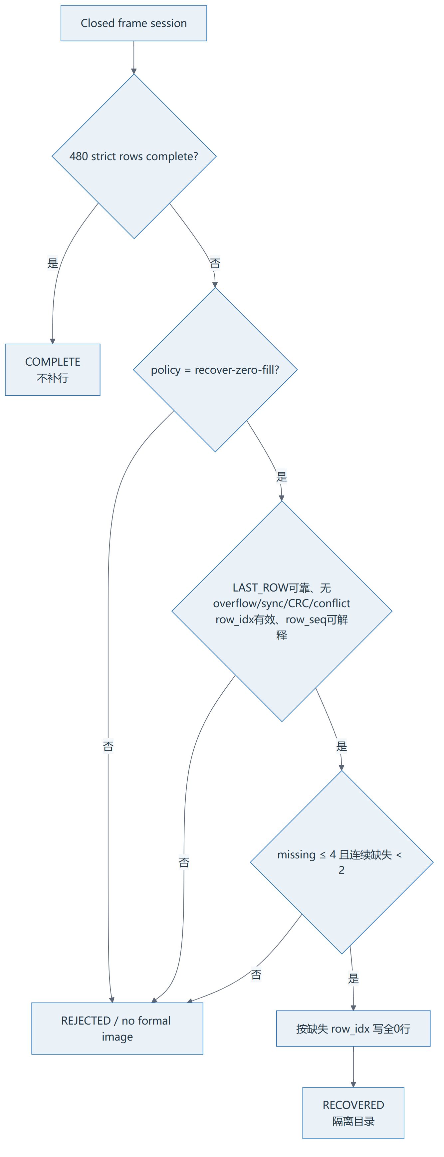
图 8-1 严格帧与zero-fill恢复的准入ASM
代码对照｜COMPLETE与RECOVERED发布分支
0262 | def archive_frame(self, frame: CompletedFrame) -> Path | None:
0263 | """Publish a COMPLETE image or an explicitly eligible RECOVERED image."""
0264 |
0265 | decision: RecoveryDecision | None = None
0266 | if frame.status is FrameStatus.COMPLETE:
0267 | self.stats.completed_frames_seen += 1
0268 | output_status = "COMPLETE"
0269 | missing_policy = MissingRowPolicy.REJECT
0270 | elif self.image_policy is ImagePolicy.RECOVER_ZERO_FILL:
0271 | self.stats.noncomplete_frames_skipped += 1
0272 | decision = self._assess_recovery(frame)
0273 | if not decision.eligible:
0274 | self._record_rejection(frame, decision)
0275 | return None
0276 | output_status = "RECOVERED"
0277 | missing_policy = MissingRowPolicy.ZERO_FILL
0278 | else:
0279 | self.stats.noncomplete_frames_skipped += 1
0280 | # Preserve strict mode's pre-change disk behavior: incomplete
0281 | # frames produce no image-side artifact. They are counted for
0282 | # truthful rate reporting but rejected.csv is recovery-mode
0283 | # evidence only.
0284 | self.stats.images_rejected += 1
0285 | assert self.stats.reject_reasons is not None
0286 | self.stats.reject_reasons["strict_requires_complete"] += 1
0287 | self._maybe_report_rates()
0288 | return None
0289 |
0290 | try:
0291 | recovered = recover_completed_frame(
0292 | frame,
0293 | self.expected_rows,
0294 | bit_order=self.bit_order,
0295 | missing_policy=missing_policy,
0296 | )
0297 | except Exception:
0298 | self.stats.recovery_failures += 1
0299 | raise
0300 |
0301 | required_height = (
0302 | 480 if output_status == "RECOVERED" else self.expected_rows
0303 | )
0304 | if (
0305 | recovered.height != required_height
0306 | or recovered.width != ROW_PIXELS
0307 | or len(recovered.pixels) != required_height * ROW_PIXELS
0308 | ):
0309 | raise ValueError(
0310 | "image geometry mismatch after publication recovery: "
0311 | f"{recovered.width}x{recovered.height}, "
0312 | f"{len(recovered.pixels)} bytes"
0313 | )
证据：D:\prg\prg_cam\prg_cam.srcs\sources_1\tx\taxi_receiver_advanced\taxi_receiver\taxi_receiver\image_pipeline.py:262
代码对照｜recover-zero-fill门槛与missing_rows计算
0413 | def _assess_recovery(self, frame: CompletedFrame) -> RecoveryDecision:
0414 | """Apply the opt-in recovery gate without relaxing packet validation."""
0415 |
0416 | reasons: list[str] = []
0417 | if self.expected_rows != 480 or frame.expected_rows != 480:
0418 | reasons.append("expected_rows_not_480")
0419 | if not 0 <= frame.frame_id <= 0xFFFF:
0420 | reasons.append("frame_id_out_of_range")
0421 |
0422 | accepted_records = [
0423 | record for record in frame.packet_records if record.accepted
0424 | ]
0425 | reliable_last = any(
0426 | record.row_idx == 479
0427 | and bool(record.row_flags & FLAG_LAST_ROW)
0428 | for record in accepted_records
0429 | )
0430 | if not reliable_last:
0431 | reasons.append("reliable_last_row_not_seen")
0432 |
0433 | all_errors = {
0434 | error
0435 | for record in frame.packet_records
0436 | for error in record.errors
0437 | }
0438 | if frame.had_overflow or "frame_overflow" in all_errors:
0439 | reasons.append("overflow")
0440 | if "bad_sync" in all_errors:
0441 | reasons.append("bad_sync")
0442 | if "crc_error" in all_errors:
0443 | reasons.append("crc_error")
0444 | if frame.conflicting_duplicates or any(
0445 | record.conflicting_duplicate for record in frame.packet_records
0446 | ):
0447 | reasons.append("conflicting_duplicate")
0448 |
0449 | # Length-invalid rows may account for a missing row, but their payload
0450 | # is never used. Any other Layer-3 error is a hard recovery rejection.
0451 | permitted_missing_row_errors = {
0452 | "length_error",
0453 | "payload_len_out_of_range",
0454 | }
0455 | unhandled_errors = sorted(all_errors - permitted_missing_row_errors - {
0456 | "frame_overflow",
0457 | "bad_sync",
0458 | "crc_error",
0459 | })
0460 | reasons.extend(f"layer3_error:{error}" for error in unhandled_errors)
0461 |
0462 | valid_row_indices = set(frame.rows)
0463 | accepted_row_indices = {record.row_idx for record in accepted_records}
0464 | if any(index < 0 or index >= 480 for index in valid_row_indices):
0465 | reasons.append("row_idx_out_of_range")
0466 | if any(index < 0 or index >= 480 for index in accepted_row_indices):
0467 | reasons.append("row_idx_out_of_range")
0468 |
0469 | valid_in_range = {
0470 | index for index in valid_row_indices if 0 <= index < 480
0471 | }
0472 | expected = set(range(480))
0473 | missing_rows = tuple(sorted(expected - valid_in_range))
0474 | max_consecutive = self._max_consecutive(missing_rows)
0475 | if not missing_rows:
0476 | reasons.append("no_missing_rows_to_recover")
0477 | if len(missing_rows) > self.max_missing_rows:
0478 | reasons.append("too_many_missing_rows")
0479 | if max_consecutive >= self.max_consecutive_missing:
0480 | reasons.append("consecutive_missing_rows")
0481 |
0482 | row_lengths = {len(frame.rows[index]) for index in valid_in_range}
0483 | if not row_lengths:
0484 | reasons.append("no_valid_rows")
0485 | elif row_lengths != {ROW_BYTES}:
0486 | reasons.append("row_byte_length_mismatch")
0487 |
0488 | if self.bit_order not in (BitOrder.MSB_FIRST, BitOrder.LSB_FIRST):
0489 | reasons.append("unsupported_pixel_format")
0490 |
证据：D:\prg\prg_cam\prg_cam.srcs\sources_1\tx\taxi_receiver_advanced\taxi_receiver\taxi_receiver\image_pipeline.py:413
表 8-1 三类输出
结果 | 条件 | 输出位置
COMPLETE | 480行均通过严格校验，不补行 | 正式cam目录
RECOVERED | 可靠LAST、无overflow/sync/CRC/conflict，missing阈值内 | recovered/frame_<id>/
REJECTED | 任一gate失败 | 不生成正式PGM/RAW；记录reason
--max-consecutive-missing 2｜当前代码把该值作为排除阈值：最大连续缺失 >=2 就拒绝，因此实际只允许单个连续缺行。

9. packed 1bpp 到 RAW/PGM
每行Camera payload为80 bytes，代表640个1-bit阈值像素。Image pipeline将每个bit展开为8-bit 0x00/0xFF，形成640×480、307200-byte显示RAW，再加P5 header得到PGM。它不是OV5640原始Y8。
表 9-1 两个image.raw的不同语义
路径 | 内容 | 480行大小
OutputRoot/cam_<id>/frame_<id>/image.raw | Layer5证据archive，80B packed行 | 38,400 B
ImagesRoot/cam<id>/<id>.raw或recovered/... | 展开后的640×480 U8 | 307,200 B
证据：taxi_receiver\threshold_recover.py:90–148,173–234；taxi_receiver\image_pipeline.py:316–397

10. 输出解耦与性能演进
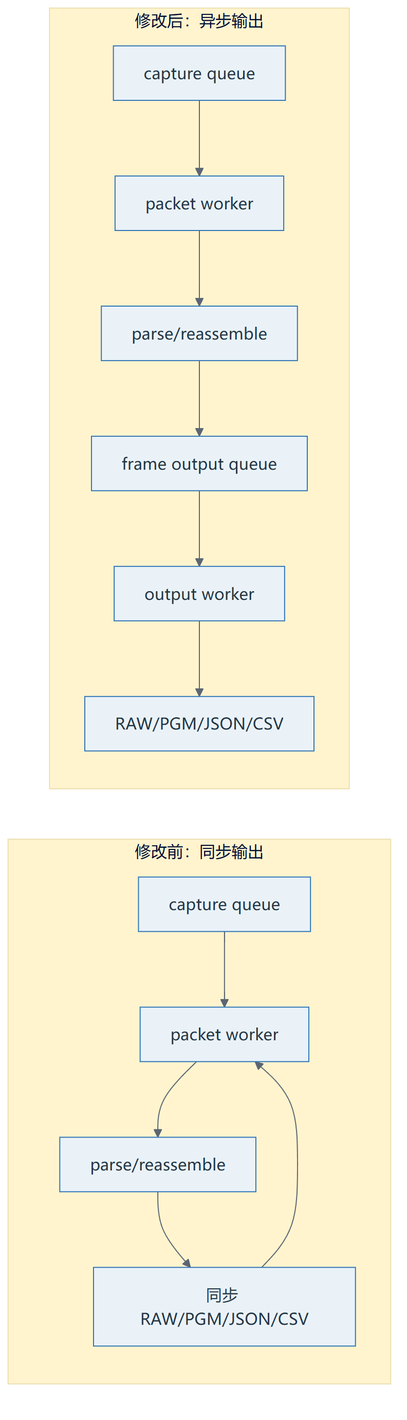
图 10-1 同步写盘热路径与当前异步输出路径
代码对照｜有界frame output queue、阻塞提交和drain/join
0023 | class AsyncCallbackDispatcher(Generic[T]):
0024 | """Run one callback on a dedicated worker with bounded buffering.
0025 |
0026 | ``submit`` blocks only when the bounded output queue is genuinely full.
0027 | It never silently drops a completed frame. This keeps slow atomic disk
0028 | publication out of the packet parsing/reassembly worker while retaining an
0029 | explicit memory limit and an observable queue high-water mark.
0030 | """
0031 |
0032 | def __init__(
0033 | self,
0034 | callback: Callable[[T], None],
0035 | *,
0036 | queue_depth: int = 256,
0037 | name: str = "taxi-frame-output",
0038 | error_sink: Callable[[str], None] | None = None,
0039 | ) -> None:
0040 | if queue_depth <= 0:
0041 | raise ValueError("queue_depth must be positive")
0042 | self.callback = callback
0043 | self.queue_depth = queue_depth
0044 | self.error_sink = error_sink or (
0045 | lambda message: print(message, file=sys.stderr)
0046 | )
0047 | self.stats = AsyncCallbackStatistics()
0048 | self._queue: queue.Queue[T | object] = queue.Queue(
0049 | maxsize=queue_depth
0050 | )
0051 | self._closed = False
0052 | self._worker = threading.Thread(
0053 | target=self._run,
0054 | name=name,
0055 | daemon=True,
0056 | )
0057 | self._worker.start()
0058 |
0059 | def submit(self, item: T) -> None:
0060 | if self._closed:
0061 | raise RuntimeError("async callback dispatcher is closed")
0062 | self._queue.put(item)
0063 | self.stats.submitted += 1
0064 | self.stats.queue_peak = max(
0065 | self.stats.queue_peak,
0066 | self._queue.qsize(),
0067 | )
0068 |
0069 | def close(self) -> None:
0070 | if self._closed:
0071 | return
0072 | self._queue.join()
0073 | self._queue.put(_STOP)
0074 | self._worker.join(timeout=30.0)
0075 | if self._worker.is_alive():
0076 | raise RuntimeError("async callback worker did not stop")
证据：D:\prg\prg_cam\prg_cam.srcs\sources_1\tx\taxi_receiver_advanced\taxi_receiver\taxi_receiver\async_sink.py:23
表 10-1 两类queue
属性 | Capture packet queue | Frame output queue
文件 | pipeline.py | async_sink.py
单位 | RawEthernetFrame | CompletedFrame
生产者 | Npcap/PCAP callback | reassembler
消费者 | taxi-worker | taxi-frame-output
默认深度 | CLI 8192；脚本65536 | 256
满时 | live显式drop；offline阻塞重试 | 阻塞，不静默丢完整图
指标 | drops/peak/producer/consumer | submitted/processed/failures/peak
异步输出把RAW/PGM/JSON/归档移出packet热路径，可吸收短时磁盘抖动；但磁盘长期慢于图像产生速度时，frame output queue仍会满，背压传播到packet worker，再导致capture queue drop。
代码对照｜summary.csv持久追加，避免O(n²)重写
0169 | def _append_summary(
0170 | self,
0171 | frame: CompletedFrame,
0172 | output_path: Path,
0173 | ) -> None:
0174 | row = self._summary_row(frame, output_path)
0175 | with self._summary_lock:
0176 | writer = self._get_summary_writer()
0177 | writer.writerow(row)
0178 | assert self._summary_handle is not None
0179 | self._summary_handle.flush()
0180 |
0181 | def _get_summary_writer(self) -> csv.DictWriter:
0182 | if self._summary_writer is not None:
0183 | return self._summary_writer
0184 |
0185 | has_content = (
0186 | self.summary_path.exists()
0187 | and self.summary_path.stat().st_size > 0
0188 | )
0189 | if has_content:
0190 | with self.summary_path.open(
0191 | newline="", encoding="utf-8"
0192 | ) as handle:
0193 | header = next(csv.reader(handle), [])
0194 | if tuple(header) != SUMMARY_FIELDS:
0195 | raise ValueError(
0196 | "existing summary.csv schema does not match current "
0197 | f"receiver: {self.summary_path}"
0198 | )
0199 |
0200 | self._summary_handle = self.summary_path.open(
0201 | "a",
0202 | newline="",
0203 | encoding="utf-8",
0204 | )
0205 | self._summary_writer = csv.DictWriter(
0206 | self._summary_handle,
0207 | fieldnames=SUMMARY_FIELDS,
0208 | )
0209 | if not has_content:
0210 | self._summary_writer.writeheader()
0211 | self._summary_handle.flush()
0212 | return self._summary_writer
证据：D:\prg\prg_cam\prg_cam.srcs\sources_1\tx\taxi_receiver_advanced\taxi_receiver\taxi_receiver\storage.py:169

11. Storage、SessionAudit与归档
表 11-1 输出机制
组件 | 职责 | 关键边界
StorageAndPipeline | temp sibling→文件关闭→os.replace→summary | Windows lock重试
CameraImagePipeline | PGM/显示RAW/JSON/rows.csv | 三文件逐个原子，不是目录事务
SessionAudit | 每包CSV、raw/effective flags、上电回退 | 审计旁路不改变严格校验
analyze_camera_archive | missing、zero-fill、row hash、跨帧复用 | 静止画面必须用hash证明
worker异常｜AsyncCallbackDispatcher会记录callback failures并打印，但CLI当前不会自动以非零退出。正式验收必须显式要求output_worker_failures=0。

12. 历史演进与因果链
- 同步接收：Capture后直接处理，功能简单但观测不足。
- Layer1–5分层：捕获、Ethernet、Camera解析、监控、重组责任分开。
- 严格Layer3：sync/payload_len/CRC/overflow/length_error不再静默。
- FrameReassembler：按(cam_id,frame_id,row_idx)支持乱序/重复/超时。
- RAW/PGM/JSON：区分packed证据与显示图像。
- recover-zero-fill：只在严格门槛内对少量missing row写0。
- async output：把慢磁盘移出packet热路径。
- summary持久追加：从每帧重写历史O(n²)改为接近O(1)。
- queue high-water与rate：可以确认瓶颈位于capture还是output。
attempt3因果关系｜877432 - 795297 = 82135；82135 + 2729 = 84864。该轮sequence gaps由capture queue drops和Layer3 length rejection解释，而CRC、固定Ethernet长度、parser errors均为0。

13. 测试与真实运行证据
表 13-1 关键测试
测试 | 证明 | 不证明
test_pipeline_synthetic:慢消费者 | 同步回调drop；异步后100 frame全处理 | 真实Npcap 120秒
test_reassembler | 不同frame_id不复用旧row | 静止场景内容正确
test_image_recovery 15项 | COMPLETE/RECOVERED/REJECTED门槛 | 上游实际缺行率
test_pcap_stdlib | 固定PCAP Layer1/2 | Camera协议
attempt3 analyzer | 1022组PGM/RAW一致、zero-fill位置正确 | 优化后性能
表 13-2 attempt3 final report
指标 | 值 | 解释
Capture ingress | 877432 | Scapy callback可见的入口，不等于NIC kernel统计
Matching Ethernet | 795297 | 进入处理队列的0x88B5
Capture queue drops | 82135 | live队列满主动drop
length errors | 2729 | 严格Camera行长度拒绝
complete/recovered | 227 / 795 | usable总1022
total usable fps | 8.453 | 低于约15fps session入口

14. 当前风险、过期项与PENDING
- frame output queue过小吸收不了突发；过大增加内存和退出drain时间。
- summary.csv每帧flush但不fsync；优雅退出可刷新，突然断电不等价于落盘保证。
- rows.csv/session_audit仍在packet observer路径批量flush，可能成为下一瓶颈。
- OutputRoot使用cam_0，ImagesRoot使用cam0，培训和脚本中必须区分。
- 固定PCAP位于被.gitignore忽略的build目录，clean clone不自动拥有。
表 14-1 过期结论
旧表述 | 当前事实
只有COMPLETE才发布 | 显式recover-zero-fill可输出RECOVERED
0x04是overflow | 0x01 overflow；0x04 FIRST_ROW
正式sync A5A5/5A5A | 当前A5A0/5A50
27/37/51项测试 | 当前实测88项
image.raw都是同一种格式 | packed archive与U8 display RAW不同
PENDING｜性能优化后的同条件120秒live final report、当前bit/固件/PCAP hash绑定、真实场景图像正确性和Npcap kernel/NIC drop统计仍未确认。

